GENERAL SKIILS MIGRATION VISA (189,190,491)-STANDARD OPERATING PROCEDURE

Document Control
Document No. | SOP-GSM-001
Version | 1.0
Department | Migration Services
Effective Date | ________________
Approved By | ________________

Purpose
This Standard Operating Procedure (SOP) establishes a consistent, efficient and compliant process for managing General Skilled Migration (GSM) visa applications, including the Skilled Independent Visa (Subclass 189), Skilled Nominated Visa (Subclass 190) and Skilled Work Regional (Provisional) Visa (Subclass 491).
This SOP aims to:
- Standardise the General Skilled Migration application process across the organisation.
- Ensure compliance with Australian migration legislation and Department of Home Affairs requirements.
- Clearly define the responsibilities of Registered Migration Agents and Consultants.
- Provide accurate migration advice based on the applicant's qualifications, occupation, work experience and eligibility.
- Maintain consistency and quality throughout the Skills Assessment, Expression of Interest (EOI), State or Territory Nomination (where applicable) and visa application process.
- Ensure all client records and supporting documents are securely managed in accordance with Yale Migration's Document Management Procedure.
- Minimise processing delays and application errors through effective quality assurance.
- Promote professional, ethical and client-focused migration services.

- Scope
This procedure applies to all General Skilled Migration (GSM) applications managed by Yale Migration.
The SOP covers:
- Initial client enquiry
- Eligibility assessment
- Occupation assessment
- Points assessment
- Skills Assessment application
- English language assessment
- Client engagement
- Document collection and verification
- Expression of Interest (EOI) preparation and submission
- State or Territory Nomination application (Subclass 190 and 491, where applicable)
- Invitation to Apply (ITA)
- Visa application preparation
- Visa lodgement
- Post-lodgement monitoring
- Requests for Further Information (Section 56)
- Visa outcome management

Roles and Responsibilities

Registered Migration Agent

Responsibilities
- Assess the client's eligibility.
- Determine the appropriate GSM visa pathway (Subclass 189, 190 or 491).
- Calculate migration points.
- Prepare and review the Skills Assessment application.
- Prepare and lodge the Expression of Interest (EOI).
- Prepare and lodge State or Territory Nomination applications (if applicable).
- Prepare and lodge the visa application.
- Conduct the final review before lodgement.
- Monitor the application and respond to Department requests.
- Advise the client on the visa outcome.

Consultant
Responsibilities
- Respond to client enquiries.
- Collect the required documents.
- Register the client in the system.
- Create the client folder.
- Upload and organise client documents.
- Endorse the complete file to the Registered Migration Agent.
- Follow up outstanding documents.
- Maintain accurate client records.

4. Tools and Systems
The following systems and resources are used throughout the General Skilled Migration (Subclass 189, 190 & 491) application process.

Systems
- ImmiAccount
- Client Management System (CMS)
- Client Engagement Log
- Secure Cloud Document Storage
- Microsoft Office / Google Workspace
- Email Management System

Standard Templates and Checklists
- General Skilled Migration (GSM) Checklist
- Skills Assessment Checklist
- English Language Checklist
- Expression of Interest (EOI) Checklist
- State/Territory Nomination Checklist
- Visa Application Checklist
- Points Test Assessment Worksheet
- Client Information Sheet
- Service Agreement
- Client Quotation Template
- Client Consent Form

5. Document Management

Every client must be registered in the Client Engagement Log to generate a Unique Client Code

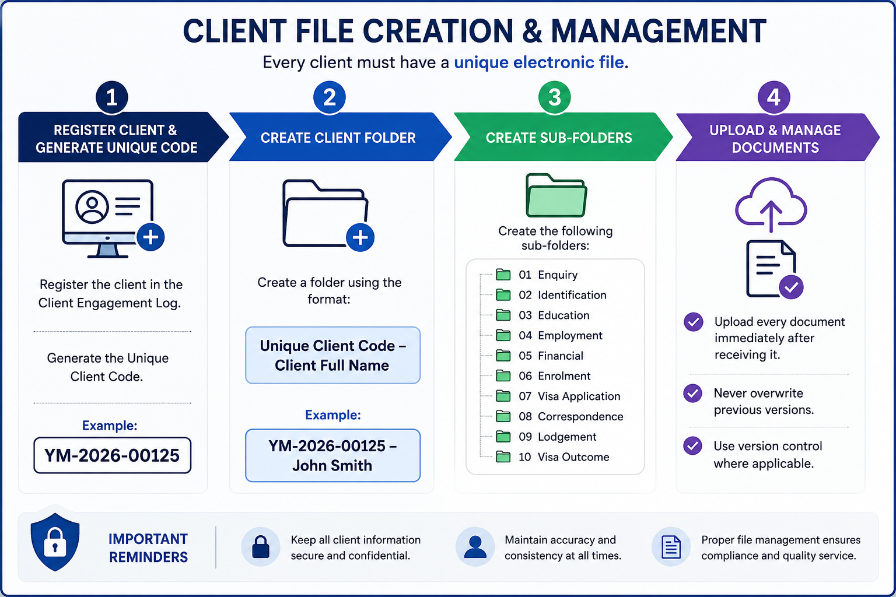

Step | Process | Procedure
1 | Register Client | Register the client in the Client Engagement Log and generate a Unique Client Code.  Example: YM-2026-00125
2 | Create Client Folder | Create a client folder using the following naming convention:  Unique Client Code – Client Full Name  Example: YM-2026-00125 – John Smith
3 | Create Sub-Folders | Create the following folders within the client's main folder:  01. Enquiry  02. Identification  03. Education  04. Employment  05. Financial  06. Enrolment  07. Visa Application  08. Correspondence  09. Lodgment  10. Visa Outcome
4 | Upload & Maintain Documents | Upload all client documents immediately upon receipt.  • Do not overwrite previous versions.  • Apply version control where necessary.  • Ensure all documents are saved in the correct sub-folder.

6. General Skilled Migration (Subclass 189, 190 & 491) Application Procedure

Step | Process | Responsible | Required Action
1 | Receive Enquiry | Consultant | Respond to client enquiries and obtain preliminary information regarding qualifications, occupation, work experience and visa objectives.
2 | Initial Assessment | Consultant | Request the completed enquiry form, resume/CV, passport, qualification documents, employment references, English test results (if available) and other supporting documents.
3 | File Endorsement | Consultant | Register the client, create the client folder, upload all received documents and endorse the complete file to the Registered Migration Agent.
4 | Eligibility Assessment | Registered Migration Agent | Assess the applicant's eligibility, nominated occupation, migration points and determine the appropriate visa subclass (189, 190 or 491).
5 | Client Consultation | Registered Migration Agent | Discuss eligibility, visa pathway, Skills Assessment requirements, English language requirements, points test, State/Territory nomination (if applicable), fees and expected processing times.
6 | Client Engagement | Registered Migration Agent | Prepare the quotation, Service Agreement and Skills Assessment checklist. Obtain the signed Service Agreement and confirm the initial payment.
7 | Skills Assessment Preparation | Registered Migration Agent | Prepare and submit the Skills Assessment application to the appropriate assessing authority.
8 | English Language Requirement | Registered Migration Agent | Verify that the applicant meets the English language requirement and advise if further testing is required.
9 | Expression of Interest (EOI) | Registered Migration Agent | Prepare and lodge the Expression of Interest (EOI) through SkillSelect.
10 | State/Territory Nomination** (190 & 491 only) | Registered Migration Agent | Prepare and submit the State or Territory Nomination application where applicable.
11 | Invitation to Apply (ITA) | Registered Migration Agent | Monitor the EOI and nomination status. Once an Invitation to Apply is received, advise the client and commence visa preparation.
12 | Visa Application Preparation | Registered Migration Agent | Prepare the visa application, upload all supporting documents and complete the ImmiAccount application.
13 | Client Review & Approval | Registered Migration Agent | Provide the completed visa application to the client for review and obtain written approval before lodgment.
14 | Final Review & Visa Lodgement | Registered Migration Agent | Conduct the final quality assurance review and lodge the visa application through ImmiAccount.
15 | Update Internal Records | Consultant | Update the Lodgment Register, record the Transaction Reference Number (TRN) and save the lodgment confirmation.
16 | Post-Lodgement Communication | Consultant | Forward the visa lodgment acknowledgement, Bridging Visa Grant (if applicable), HAP ID and health examination instructions to the client.
17 | Application Monitoring | Registered Migration Agent | Monitor the application, respond to Requests for Further Information (Section 56) and provide updates to the client.
18 | Visa Outcome | Registered Migration Agent | Notify the client of the visa outcome and provide advice regarding visa conditions and next steps.
19 | File Closure | Consultant | Save all final correspondence, update internal records and archive the client file in accordance with the Document Management Procedure.

7. Quality Control Checklist
The Registered Migration Agent must complete the following quality assurance checks before lodging any General Skilled Migration (Subclass 189, 190 or 491) visa application. No application is to be lodged until all applicable items have been reviewed and confirmed.
Quality Check | Completed (✓)
Client identity has been verified using a valid passport or government-issued identification. | ☐
Passport is valid for the intended visa application period. | ☐
Nominated occupation has been confirmed as eligible. | ☐
Applicant meets the eligibility requirements for the selected GSM visa subclass. | ☐
Migration points have been correctly calculated and verified. | ☐
Skills Assessment has been obtained and is valid. | ☐
English language requirement has been met and valid evidence has been provided. | ☐
State or Territory Nomination has been approved (Subclass 190 or 491 only). | ☐
Expression of Interest (EOI) has been submitted correctly. | ☐
Invitation to Apply (ITA) has been received before visa lodgement. | ☐
Health examination requirements have been explained and HAP ID issued where applicable. | ☐
Police Clearance Certificates have been obtained where required. | ☐
All supporting documents have been reviewed for completeness, accuracy and consistency. | ☐
Client information is consistent across all documents and application forms. | ☐
All required declarations and consent forms have been completed and signed. | ☐
Client has reviewed and approved the final visa application before lodgement. | ☐
Government Visa Application Charges (VAC) and professional fees have been confirmed with the client. | ☐
All supporting documents have been correctly named, organised and saved in accordance with the Document Management Procedure. | ☐
Registered Migration Agent has completed the final compliance review and approved the application for lodgement. | ☐
Visa application has been successfully lodged through ImmiAccount. | ☐
Transaction Reference Number (TRN), lodgement confirmation and post-lodgement records have been saved in the client file. | ☐

Important
- Any missing or inconsistent information must be resolved before the application is lodged.
- Skills Assessment, English language test results, and Invitations to Apply (ITA) must remain valid at the time of visa lodgement.
- For Subclass 190 and Subclass 491 applications, State or Territory nomination must be approved before lodging the visa application.
- The Registered Migration Agent is responsible for ensuring the application complies with current Australian migration legislation, Department of Home Affairs policy, and professional obligations before lodgement.
- Any Request for Further Information (Section 56) issued by the Department of Home Affairs must be responded to before the specified deadline.

8. Compliance and Disclosure
Yale Migration is committed to maintaining the highest standards of professionalism, ethical conduct and compliance with Australian migration legislation.
All staff involved in Graduate Visa applications must comply with the following requirements:

Legislative Compliance
- Comply with all applicable Australian migration legislation, regulations and policy requirements.
- Follow all requirements of the Department of Home Affairs when preparing and lodging visa applications.
- Ensure that all information provided in a visa application is accurate, truthful and supported by appropriate evidence.

Professional Responsibilities
- Only a Registered Migration Agent may provide migration advice or make legal representations regarding visa matters.
- Consultants and administrative staff must not provide migration advice unless authorized to do so.
- Any complex migration issues must be referred to the Registered Migration Agent.

Client Confidentiality
- Protect all client information in accordance with Australian privacy requirements and the agency's privacy policy.
- Client information must only be accessed by authorized staff for legitimate business purposes.
- Client documents must be stored securely within the agency's approved document management system.

Accuracy and Record Management
- Maintain complete, accurate and up-to-date client records always.
- Record all client communications, advice provided, and documents received or submitted.
- Ensure all electronic files follow the agency's document naming and filing procedures.

Fee Disclosure
Before commencing any work, the client must receive clear written information regarding:
- Professional service fees.
- Government Visa Application Charges (VAC).

Client Acknowledgement
Before visa lodgment, the client must acknowledge that:
- All information provided is true, complete and accurate.
- They have reviewed and approved the final visa application.
- They understand their obligations as a Student Visa holder.
- They understand that providing false or misleading information may result in visa refusal or cancellation.

Visa Outcome Disclaimer
Yale Migration will prepare and manage every application with due skill, care and diligence. However, the approval or refusal of any visa application is solely at the discretion of the Department of Home Affairs.
Neither Yale Migration nor the Registered Migration Agent can guarantee the grant of a visa, as each application is assessed on its individual merits and in accordance with Australian migration legislation and policy.

